Thomasville Heights Off-site Parking Lot with Shuttle Service
456 McDonough Blvd Atlanta, GA 30315

Participating Firms:
AGG | Epiq | Veritext
11th Circuit Courts | Kilpatrick Townsend | Hartman Simons Wood
Greenberg Traurig | William Teusink | Weathington McGrew
Taylor English | GAPABA | Bloom Parham
Swift Currie | Paul Hastings | Polsenilli

Driving Directions from 85/75 North:
Follow I-75 S/I-85 South to Exit 244 for University Ave
Use the left 2 lanes to turn left onto GA-54 S/University Ave SW
Turn right onto McDonough Blvd SE and drive for about 1mile
The parking lot is on the left directly after the brick church and traffic light
Sawtell Ave SE & McDonough is the closest intersection

Driving Directions From 85/75 South:
Follow I-75 and I-85 North to University Ave SW
Take exit 244 from I-75 N for University Ave
Turn right onto University Ave SW
Turn right onto McDonough Blvd SE and drive for about 1 mile
The parking lot is on the left directly after the brick church and traffic light
Sawtell Ave SE & McDonough is the closest intersection

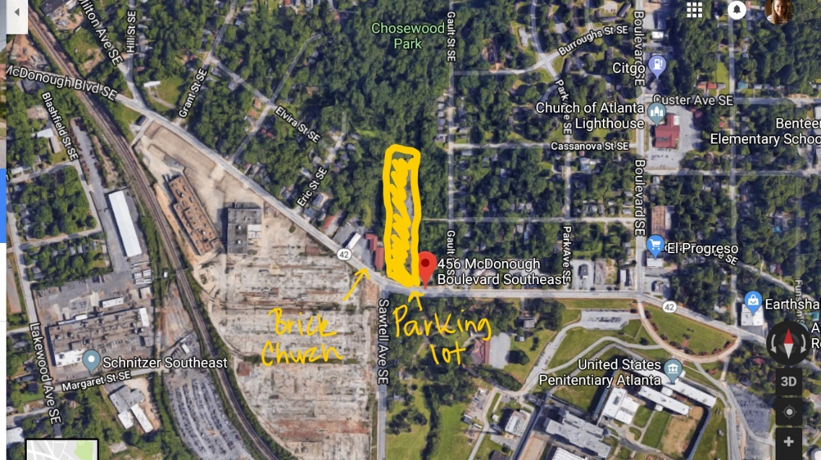

Price Middle School
1670 Benjamin Weldon Bickers Dr SE, Atlanta, GA 30315

Participating Firms:
Alston & Bird | Fulton Co. Bench
Caplan Cobb | Hall Booth Smith
Balch & Bingham | Heninger Garrison Davis
Morris Manning Martin | McGuire Woods

Driving Directions From 85/75 South:
Follow I-75 S and I-85 S to GA-54 S/University Ave SW, exit 244
Use the left 2 lanes to turn left onto GA-54 S/University Ave SW
Turn right onto Pryor Rd SW
Turn left onto Meldon Ave SE
Turn right onto Benjamin Weldon Bickers Dr SE
The school will be on your left with parking in the lot and on the street

Driving Directions from 85/75 North:
Follow I-75 and I-85 North to University Ave SW
Take exit 244 from I-75 N for University Ave
Turn right onto University Ave SW at exit ramp
Turn right onto Pryor Rd SW
Turn left onto Meldon Ave SE
Turn right onto Benjamin Weldon Bickers Dr SE
The school will be on your left with parking in the lot and on the street

